**STATS 295: Bayes-I**

**Ankoor Bhagat**

**UCI ID: 92963676**

***Homework # 3***

***Exercise 5.30***

Code:

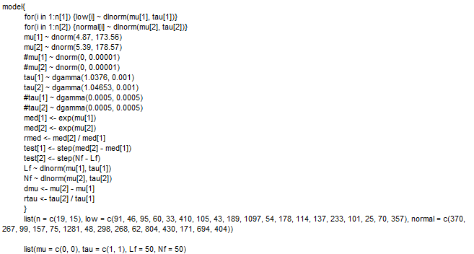

*Sensitivity Analysis Cases*

**Case – A: Given**

μ1 ~ Normal(0, 0.00001), μ2 ~ Normal(0, 0.00001), τ1 ~ Gamma(0.001, 0.001), and τ2 ~ Gamma(0.001, 0.001)

**Case – B: Commented out prior**

μ1 ~ Normal(4.87, 3471.2), μ2 ~ Normal(5.39, 357.14), τ1 ~ Gamma(1.0376, 0.001), and τ2 ~ Gamma(1.04653, 0.001)

**Case – C: Decreasing variance – Precision = 0.001**

μ1 ~ Normal(0, 0.001), μ2 ~ Normal(0, 0.001), τ1 ~ Gamma(0.001, 0.001), and τ2 ~ Gamma(0.001, 0.001)

**Case – D: Increasing variance – Precision = 0.000001**

μ1 ~ Normal(0, 0.000001), μ2 ~ Normal(0, 0.000001), τ1 ~ Gamma(0.001, 0.001), and τ2 ~ Gamma(0.001, 0.001)

**Case – E: Changing “b” in Gamma = 0.01**

μ1 ~ Normal(0, 0.00001), μ2 ~ Normal(0, 0.00001), τ1 ~ Gamma(0.001, 0.01), and τ2 ~ Gamma(0.001, 0.01)

**Case – F: Changing “b” in Gamma = 0.1**

μ1 ~ Normal(0, 0.00001), μ2 ~ Normal(0, 0.00001), τ1 ~ Gamma(0.001, 0.1), and τ2 ~ Gamma(0.001, 0.1)

**Case – G: Changing “a” and “b” in Gamma by using W = 0.5, “Wa” and “Wb” in Gamma**

μ1 ~ Normal(0, 0.00001), μ2 ~ Normal(0, 0.00001), τ1 ~ Gamma(0.0005, 0.0005), and τ2 ~ Gamma(0.0005, 0.0005)

**Case – H: Increasing variance in Commented out prior by 2 times.**

μ1 ~ Normal(4.87, 173.56), μ2 ~ Normal(5.39, 178.57), τ1 ~ Gamma(1.0376, 0.001), and τ2 ~ Gamma(1.04653, 0.001)

|  |  |  |  |  |  |  |  |  |
| --- | --- | --- | --- | --- | --- | --- | --- | --- |
|  | **Sensitivity Analysis (Mean values shown below)** | | | | | | | |
|  | **Case - A** | **Case - B** | **Case - C** | **Case - D** | **Case - E** | **Case - F** | **Case - G** | **Case - H** |
| **Lf** | 189.100 | 199.300 | 189.100 | 189.100 | 189.300 | 190.500 | 189.100 | 197.700 |
| **Nf** | 446.500 | 346.700 | 446.300 | 446.500 | 446.900 | 451.000 | 446.500 | 348.900 |
| **dmu** | 0.784 | 0.535 | 0.784 | 0.784 | 0.784 | 0.784 | 0.784 | 0.549 |
| **med[1]** | 113.500 | 129.100 | 113.500 | 113.500 | 113.500 | 113.500 | 113.500 | 128.100 |
| **med[2]** | 251.100 | 220.600 | 251.000 | 251.100 | 251.100 | 251.200 | 251.100 | 221.800 |
| **mu[1]** | 4.705 | 4.860 | 4.705 | 4.705 | 4.705 | 4.705 | 4.705 | 4.850 |
| **mu[2]** | 5.489 | 5.395 | 5.489 | 5.489 | 5.489 | 5.489 | 5.489 | 5.399 |
| **rmed** | 2.332 | 1.713 | 2.332 | 2.332 | 2.332 | 2.334 | 2.332 | 1.741 |
| **rtau** | 1.069 | 1.113 | 1.069 | 1.069 | 1.069 | 1.066 | 1.069 | 1.111 |
| **tau[1]** | 1.124 | 1.276 | 1.124 | 1.124 | 1.122 | 1.110 | 1.124 | 1.277 |
| **tau[2]** | 1.068 | 1.286 | 1.068 | 1.068 | 1.066 | 1.052 | 1.068 | 1.284 |
| **test[1]** | 0.985 | 1.000 | 0.985 | 0.985 | 0.985 | 0.985 | 0.985 | 1.000 |
| **test[2]** | 0.708 | 0.662 | 0.708 | 0.708 | 0.708 | 0.707 | 0.708 | 0.665 |

***Exercise 5.31***

Θ ~ Gamma(1, 1), sample size =2, y1 = 5, y2 = 10. Estimate Θ and probability of no kills e-Θ.

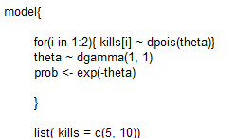



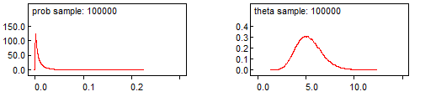

*Now normal approximation to the posterior.*

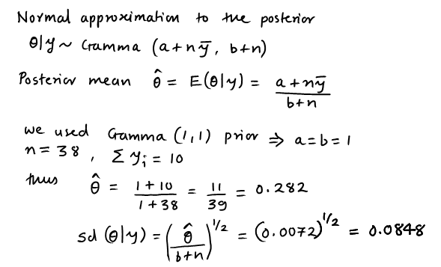

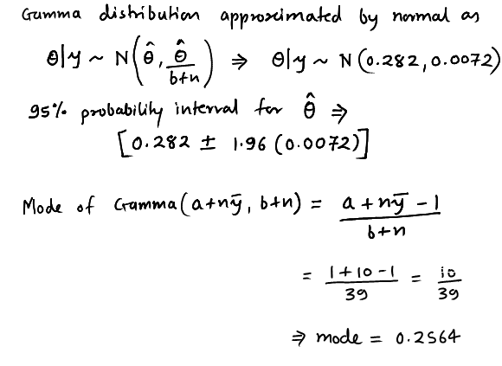

**Θ|y ~ Normal(0.282, 0.0072)**

Mean = Mode = 0.282, Standard deviation = 0.0848, 95% probability interval = [0.02678 <= Θ <= 0.2961]

**Result from WinBUG using prior Θ ~ Gamma(1, 1)**

Mean = 5.333, Mode = 0.2564, Standard Deviation = 1.34, 95% probability interval = [3.046 <= Θ <= 8.278]

Based on the comparison above the normal approximation to the posterior does not provide a reasonable approximation to the posterior **Θ|y ~ Gamma(a+n*y, bar, b+n)** or **Θ|y ~ Gamma(11, 39)**

***Exercise 5.32***

Θ0 = 10, c = 30, and α = 0.95. Need to find a(b), and 95 %tile of Gamma(a(b), b)

R-Code:

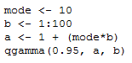

Output:

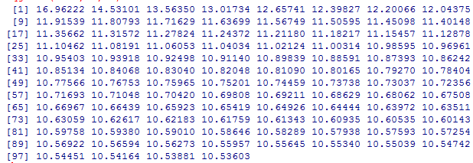

*The quantiles do not reach 30 (they range from 16.9 to 10.5), now we will repeat the process again with different b.*

R-Code:

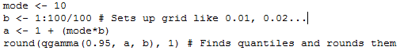

Output:

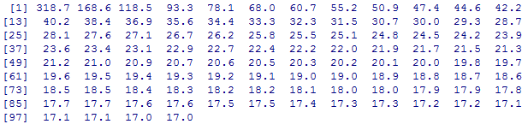

*The appropriate %tile 30 is in the 22nd spot => the appropriate value of b in in the 22nd place of the b vector, which is*

*b[22] = 22/100 = 0.22, thus a = 1 + (0.22)*10 = 3.2*

Θ ~ Gamma(3.2, 0.22)

Now Θ0 = 15, c = 30, and α = 0.95. Need to find a(b), and 95 %tile of Gamma(a(b), b)

R-Code:



Output:

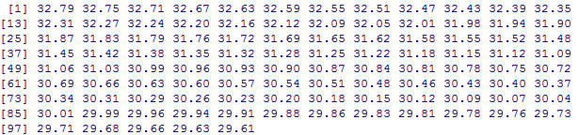

*The appropriate %tile 30 is in the 85th spot => the appropriate value of b in in the 85th place of the b vector, which is*

*b[85] = 300/1000 + 85/1000 = 0.385, thus a = 1 + (0.385)*15 = 6.775*

Θ ~ Gamma(6.775, 0.385)

***Exercise 5.34***

Expert provides best guess of Θ = 1 armadillo, and is 95% sure that the mean daily number of kills is under 1.5 armadillos. Now Θ0 = 1, c = 1.5, and α = 0.95. Need to find a(b), and 95 %tile of Gamma(a(b), b)

R-Code:

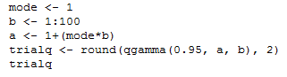

*The appropriate %tile 1.5 is in the 17th spot => the appropriate value of b in in the 17th place of the b vector, which is*

*b[17] = 17 thus a = 1 + (1)*17 = 18*

Θ ~ Gamma(18, 17) and 95% of this distribution is 1.499955

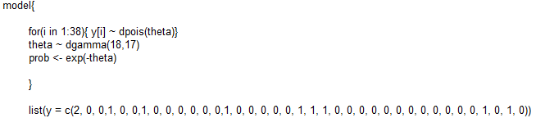



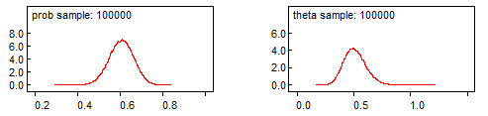

*The estimated probability that a hunter comes home without bagging an armadillo is* ***0.6039***

***Exercise 5.36***

Mode for Θ1 = 3, and 95 %tile = 10; Mode for Θ2 = 1, and 95 %tile = 7. Now using R we will find:

Θ1 ~ Gamma(a1, b1) and Θ2 ~ Gamma(a2, b2)

R-Code (Θ1)

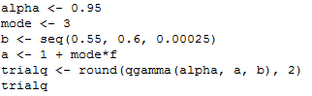

*The appropriate %tile 10 is in the 111th spot => the appropriate value of b in in the 111th place of the b vector, which is b[111] = 0.55 + (0.00025)*111 = 0.577, thus a = 1 + (0.577)*3 = 2.731.* Θ1 ~ Gamma(2.731, 0.577). Similarly for Θ2 we get the appropriate %tile 7 is in the 33rd spot, thus b[33] = 0.55 + (0.00025)*33 = 0.558, and a = 1 + (0.558)*1 = 1.558. Θ2 ~ Gamma(1.558, 0.558). Now using these priors in the WinBUGS code.

First using prior Θi ~ Gamma(0.5, 0.001) for i = 1, 2

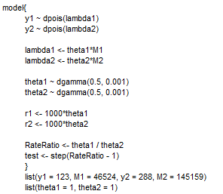

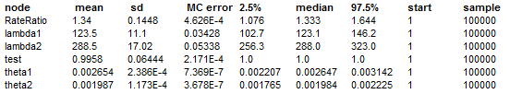

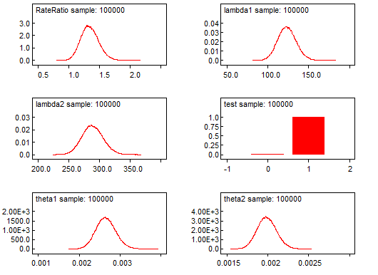

Now using Θ1 ~ Gamma(2.731, 0.577), Θ2 ~ Gamma(1.558, 0.558) priors in the WinBUGS code.

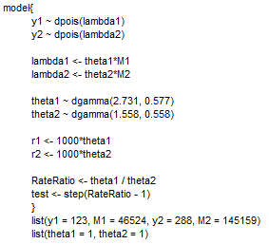

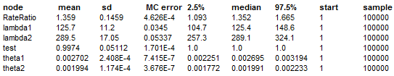

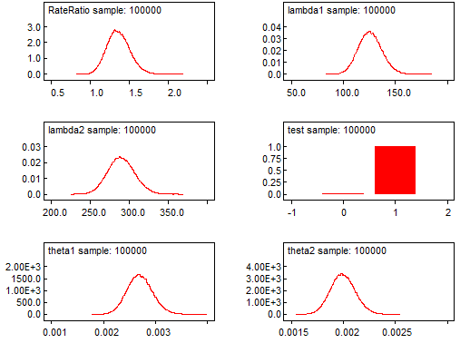

|  |  |  |  |  |  |  |  |
| --- | --- | --- | --- | --- | --- | --- | --- |
| **Theta priors** | **node** | **mean** | **sd** | **2.50%** | **median** | **97.50%** | **sample** |
| Θ1 ~ Gamma(2.731, 0.577), Θ2 ~ Gamma(1.558, 0.558) | RateRatio | 1.359 | 0.1459 | 1.093 | 1.352 | 1.665 | 100000 |
| lambda1 | 125.7 | 11.2 | 104.7 | 125.4 | 148.6 | 100000 |
| lambda2 | 289.5 | 17.05 | 257.3 | 289.1 | 324.1 | 100000 |
| test | 0.9974 | 0.05112 | 1 | 1 | 1 | 100000 |
| theta1 | 0.002702 | 2.41E-04 | 0.002251 | 0.002695 | 0.003194 | 100000 |
| theta2 | 0.001994 | 1.17E-04 | 0.001772 | 0.001991 | 0.002233 | 100000 |
| Θi ~ Gamma(0.5, 0.001) for i = 1, 2 | RateRatio | 1.34 | 0.1448 | 1.076 | 1.333 | 1.644 | 100000 |
| lambda1 | 123.5 | 11.1 | 102.7 | 123.1 | 146.2 | 100000 |
| lambda2 | 288.5 | 17.02 | 256.3 | 288 | 323 | 100000 |
| test | 0.9958 | 0.06444 | 1 | 1 | 1 | 100000 |
| theta1 | 0.002654 | 2.39E-04 | 0.002207 | 0.002647 | 0.003142 | 100000 |
| theta2 | 0.001987 | 1.17E-04 | 0.001765 | 0.001984 | 0.002225 | 100000 |

*The results are similar.*

**Exercise 5.38**

**WinBUGS code to handle the model:**

